**Ideation Phase**

**Define the Problem Statements**

|  |  |
| --- | --- |
| Date | 12 June 2025 |
| Team ID | LTVIP2025TMID40025 |
| Project Name | Clean Tech: Transforming waste into Transfer Learning |
| Maximum Marks | 2 Marks |

**Customer Problem Statement Template:**

Create a problem statement to understand your customer's point of view. The Customer Problem Statement template helps you focus on what matters to create experiences people will love.

A well-articulated customer problem statement allows you and your team to find the ideal solution for the challenges your customers face. Throughout the process, you’ll also be able to empathize with your customers, which helps you better understand how they perceive your product or service.

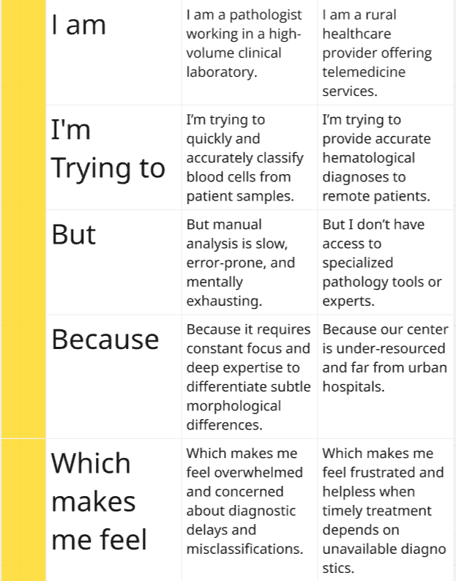

Reference: <https://miro.com/app/board/uXjVIkW2Byw=/?share_link_id=121637618886>

**Example:**

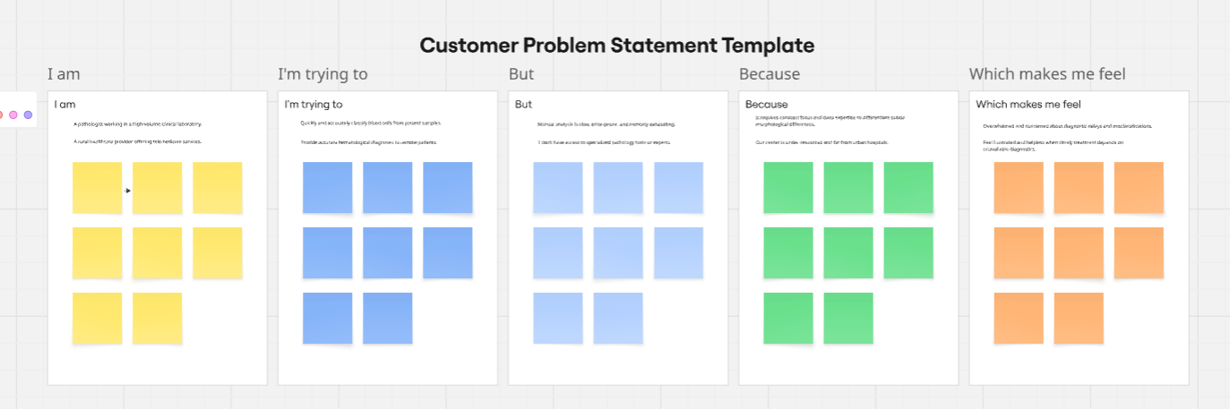

|  |  |  |  |  |  |
| --- | --- | --- | --- | --- | --- |
| **Problem Statement (PS)** | **I am (Customer)** | **I’m trying to** | **But** | **Because** | **Which makes me feel** |
| PS-1 | Pathologist | Classify blood cells | Manually analysis is slow, error-prone, and mentally exhausting. | it requires constant focus and deep expertise | Overwhelmed and concerned about diagnostic delays |
| PS-2 | Rural Health care | Accurate hematological diagnoses | No access to specialized pathology tools or experts | Center is under resourced and far from under resourced and far from hospitals | Makes feel frustrated and helpless when timely depends on unavailable diagnostics. |